**“Online Learning Management System”**

**BY**

#### Uden Shakya 7-2-282-308-2019

ST. XAVIER’S COLLEGE

*A Summer Project Report Submitted to*

#### Faculty of Management, Tribhuvan University

###### in partial fulfillment of the requirements for the degree of

**Bachelor of Information Management**

Maitighar, Kathmandu July, 2023

## STUDENT DECLARATION

This is to certify that I have completed the Summer Project entitled “**Online Learning Management System**” under the guidance of “**Er. Rajan Karmacharya**” in partial fulfillment of the requirements for the degree of **Bachelor of Information Management** at Faculty of Management, Tribhuvan University. This is my original work and I have not submitted it earlier elsewhere.

Date: July, 2023 Name: Uden Shakya

Signature: Roll No. 10254/19

## CERTIFICATE FROM THE SUPERVISOR

This is to certify that the summer project entitled “**Online Learning Management System**” is an academic work done by “**Uden Shakya**” submitted in the partial fulfillment of the requirements for the degree of **Bachelor of Information Management** at Faculty of Management, Tribhuvan University under my guidance and supervision. To the best of my knowledge, the information presented by him in the summer project report has not been submitted earlier.

Signature of the Supervisor

Er. Rajan Karmacharya

Chief Technology Officer

July, 2023

## ACKNOWLEDGEMENT

This project has been a great opportunity for me to explore my knowledge and skill. The success and final outcome of this project required a lot of guidance and assistance from many people and I am extremely privileged to have got this all along the completion of my project. All that I have done is only due to such supervision and assistance and I would not forget to thank them. I would like to extend my sincere thanks to all of them.

I own my deep gratitude to the Head of Department, **Mr. Ganesh Yogi,** for his guidance and patience during this project and also for his mentoring throughout all the brief encounters with the research and development aspects of this project. Furthermore, I would like to thank the Project Supervisor **Er. Rajan Karmacharya (CTO)** of Department of Computer Science, all my friends who help me complete my project and St. Xavier’s College for providing me valuable guidelines, supervision and suggestions to successfully complete this project.

I would like to express my sincere thanks to all my teachers for guiding me in all possible ways to achieve my ultimate goal. Their inspiration and helpful guidance has made this project come to a success.

I thank and my appreciation also goes to my colleague in developing the project and people who have willingly helped me out with their abilities.

**Uden Shakya**

**(TU Exam Roll No. 10254/19)**

## EXECUTIVE SUMMARY

##### In this project, learners are able to study at their own pace and convenience, from any location with an internet connection. We enter into Web page by logging with User Name and Password. Then we select the content we want to study. The study material are in notes and videos form for easy learning and understanding the subject. We can also do quiz to test our knowledge about the subject.

The project has features such as user-friendly interface, robust features, scalability, and customizability. It leverages the widely used PHP programming language, ensuring compatibility with various web servers and databases. The system's responsive design and mobile compatibility provide a seamless learning experience across devices.

The Online Learning Management System offers a comprehensive and scalable solution for delivering, managing, and tracking online courses and training programs. Its user-friendly interface, extensive features, and mobile compatibility make it an ideal choice for educational institutions and organizations seeking to enhance their training capabilities. With the potential to reduce costs, improve learner engagement, and streamline administrative tasks, the project is poised to contribute to the success of online learning initiatives.

**Keywords:** Online Learning**,** Courses**,** Education**,** Student**,** Teacher

## TABLE OF CONTENTS

*STUDENT DECLARATION**i*

*CERTIFICATE FROM THE SUPERVISOR**ii*

*ACKNOWLEDGEMENT**iii*

*EXECUTIVE SUMMARY**iv*

*LIST OF TABLES vii*

*LIST OF FIGURES viii*

*ABBREVIATIONS ix*

CHAPTER 1 – INTRODUCTION 1

* 1. Background 1
  2. Introduction of the organization 1
  3. Current situation of the organization 1
  4. Issue of report 1
  5. Objective of the report 2
  6. Methodology/Procedure adopted for writing the report 2
     1. Project Framework 2
     2. Data and Information 3
     3. Tools Used 3
     4. Feasibility Analysis 4

Chapter 2 - Tasks and Activities Performed 5

* 1. Analysis of Tasks, Activities, Problems, Issues 5
     1. System Analysis 5
     2. Requirement Analysis 5
     3. Analysis of Tasks and Activities Performed 5
     4. Analysis of Problems and Issues 6
     5. Literature Review 6
     6. Time Schedule and Gantt Chart 8
  2. Analysis of Possible Solutions 8
     1. Requirement Analysis 9
        1. Functional Requirement 9
        2. Non-functional Requirement 12
     2. System Requirement 13
     3. Solution Design 13
     4. Analysis of possible solutions 24
     5. Testing 24
     6. Level of Testing 24
        1. Unit Testing 24
        2. Integration Testing 25
        3. System Testing 25
  3. Findings/Result 29
     1. Output 29

Chapter 3 – Discussion and Conclusion 33

* 1. Discussions 33
     1. Critical Analysis 33
     2. Assumptions 33
     3. Limitations 33
     4. Future enhancements 33
  2. Conclusion 34

**REFERENCES** **35**

## LIST OF TABLES

Table 1: Time Schedule 8

Table 2: User Login 9

Table 3: User Registration 9

Table 4: Admin Login 9

Table 5: Manage Courses 10

Table 6: Manage Videos 10

Table 7: Manage Quizzes 10

Table 8: Hardware Requirements 13

Table 9: Software Requirements 13

Table 10: Test Case 25

#### LIST OF FIGURES

Figure 1: Gantt chart 8

Figure 2: Use Case Diagram of User/Student 11

Figure 3: Use Case Diagram of Admin/Teacher 12

Figure 4: System Flow Diagram 14

Figure 5: Context Diagram 15

Figure 6: DFD Level 1 16

Figure 7: DFD Level 2 (Expanding 2.0) 16

Figure 8: DFD Level 2 (Expanding 4.0) 16

Figure 9: Class Diagram 18

Figure 10: Sequence diagram of Admin 19

Figure 11: Sequence diagram of User 20

Figure 12: Activity Diagram of Admin 21

Figure 13: Activity Diagram of User 22

Figure 14: ER Diagram 23

Figure 15: Admin Login 26

Figure 16: Add Course 26

Figure 17: Add Course Validation 27

Figure 18: User Registration 27

Figure 19: User login 28

Figure 20: Home Page 29

Figure 21: Course Page 29

Figure 22: Admin Dashboard 30

Figure 23: Notes Page 31

Figure 24: Video Page 31

Figure 25: Quiz Page 32

**ABBREVIATIONS**

BIM Bachelor of Information Management

DFD Data Flow Diagram

ER Entity Relationship

UML Unified Modeling Language

HTML Hypertext Markup Language

CSS Cascading Style Sheets

PHP Hypertext Preprocessor

MYSQL Structured Query Language

DBMS Database Management System

SQL Structured Query Language

URL Uniform Resource Locator

XAMPP Apache(A), MySQL(M),

JS JavaScript

**CHAPTER 1: INTRODUCTION**

**1.1 Background**

Online learning have gained significant popularity in recent years due to the growth of e-learning and distance education. These systems provide a platform for educational institutions, trainers, and organizations to deliver courses and educational content to learners in a virtual environment. PHP, being a widely used server-side scripting language, is often employed for developing online learning management systems due to its versatility and ease of use. Online learning management systems have revolutionized education by providing accessible and scalable platforms for delivering quality education globally. These systems enable learners to access educational resources anytime, anywhere, and offer educators tools to create engaging and interactive learning experiences.

This report is based on the organization's visit made to Adarsha Vidya Mandir(AVM), Manbhawan, Lalitpur. It has been developed based on the inside learnt and observed during the visits to the organization. The problem related to the organization is solved with the help of IT. Website development is made to overcome problems. This project is implemented using databases and PHP. Its main aim is to provide online vehicle parking through the online platforms.

**1.2 Introduction of an organization**

Adarsha Vidya Mandir (AVM) Higher Secondary School is one of the oldest and largest schools in Nepal. It was established in 1966 AD at Manbhawan, Lalitpur by a pioneer in the field of education, the late Satya Narayan Bahadur Shrestha. The main motto of the school is “be good do good” . The school focuses on character building, and all-round development along with academic excellence so that these good citizens will play a substantial role in building a prosperous, peaceful and happy society. (*AVM School,* n.d.)

**1.3 Current situation of the organization**

The school has been providing quality education for a long time but due to the ever changing environment in technology, students are not able to fully learn about various topics such as coding, programming, software, etc. Students are required to study the courses from class and books. The school heavily relies on the traditional education approach and new modern approach of online learning such be used. (*AVM School,* n.d.)

**1.4 Issue of the report**

The current situation is very limited to few resources, students are unable to get knowledge more than that the lecture provides to them. There are no proper content for students that wants to extend their knowledge beyond their curriculum via internet. Traditional education system has become outdated so new system such as online education system has to be used alongside the traditional approach. Also student may not have access to quality education and teacher.

**1.4 Objectives of the report:**

With the Online E-learning management system, it aims to clear the short comings of the currently existing traditional system

* Providing the facility of online learning for the students of AVM school.
* To make it convenient to learn free new courses in free time
* Providing quality learning contents and updating them

**1.5 Methodology/Procedure adopted for writing the report**

Methodology is the systematic, theoretical analysis of the methods applied to a field of study. It comprises the theoretical analysis of the body of methods and principles associated with a branch of knowledge. It is the general research strategy that outlines the way in which research is to be undertaken and, among other things, identifies the methods to be used in it.

**1.6 Methodology/Procedure adopted for writing the report**

**1.6.1 Project Framework**

A project to run smoothly, on time and produce great result requires a good project framework. A good project framework is combination of these processes:

1. **Initiation:**

Project was initiated on the beginning of session

1. **Planning**

A proper plan was made by breaking down project into manageable tasks throughout the semester.

1. **Requirement Collection and Analysis**

In the phase of information was collected from various elearning sites how to develop a proper online learning system.

1. **Designing**

In the design phase, the author had focused on how to simplify the websites for the consumers and designed in such a way that helps them easily navigate through the application.

1. **Coding**

In this project coding is done with HTML, CSS and its front-end framework i.e. Bootstrap, JavaScript. MySQL has been used for storing the information into databases, PHP for making the webpage more interactive and dynamic. Similarly, font awesome have also been used in this project.

1. **Testing**

In this phase, the coding was tested accordingly. Every single task of the project has been tested in order to make the system meticulous.

1. **Implementation**

After the successful testing of the system, the project was ready for the implementation.

1. **Software evolution and deployment**

In this phase, the reviews and feedback from the users will be considered and the system will be re-developed accordingly unless it reaches the level of satisfaction. And new demand or technological change, system would evolve accordingly.

**1.6.2 Data and Information:**

The data are raw materials which after processing making the use various technology and logic transforms into information. For, conducting this project report the author collected the data and information from various sources:

1. **Primary Sources:**

These are the sources from which information is collected through self-involvement. These are the reliable resources that give accurate information. It involves an artifact, a document diary, autobiography, a recording, or any other source of information that was created at the time under study.

1. **Secondary Sources:**

Other required information for this project was collected through various other sources such as case studies of previous years, websites, articles, review articles, observations, etc.

**1.6.3 Tools used:**

The following tools were used to develop this project:

* **HTML**

Hypertext Markup Language is the standard markup language for creating web pages and web applications. HTML 5 is used to design the frontend part of the web page in this system.

* **CSS**

Cascading Style Sheets (CSS) is a style sheet language used for describing the presentation of a document written in a markup language like HTML. CSS is used for the frontend part of web application.

* **Bootstrap**

Bootstrap is a free front-end framework for faster and easier web development. It includes HTML and CSS based design templates for typography, forms, buttons, tables, navigation, modals, image carousels and many other, as well as optional JavaScript plugins and also gives the ability to easily create responsive designs.

* **PHP**

PHP is an open-source, interpreted, and object-oriented scripting language that can be executed at the server-side. PHP is well suited for web development. Therefore, it is used to develop web applications (an application that executes on the server and generates the dynamic page.).

* **MySQL**

MySQL is a relational database management system based on SQL – Structured Query Language. The application is used for a wide range of purposes, including data warehousing, e-commerce, and logging applications. The most common use for mySQL however, is for the purpose of a web database.

**1.6.4 Feasibility Analysis**

1. **Technical Feasibility**

The software is developed using HTML, CSS, Java, MySQL, Bootstrap and Javascript which are all readily available. This application is technically feasible as highly expert person is not required to use this application. Normally, users can visit the website and start learning from various learning materials that are updated by the admin teachers.

1. **Economic Feasibility**

It is basically an analysis of viability of an idea under the available budget. This application is economically feasible as this application just needs a laptop or mobile and internet connection to function. Economically infeasible work is better not to even commence.

1. **Legal Feasibility**

Since, current version of the project is mostly concern with education purpose for learning, the author assures that there are no any legal barriers to develop the project. Thus, the project is legally feasible.

1. **Operational Feasibility**

This application is developed with simple, attractive and is user friendly interfaces which can be used by all the people who are accessing this application from their personal computer for required information. Thus, this project is operationally feasible.

1. **Schedule Feasibility**

The development process is planned to reach designing phase till the first week of May, which gives us a windows of roughly 2 months. Although this may be a tight fit for a perfect, final system, as the Incremental Model is being followed in the SDLC, this is enough time to develop a working first version of the project.

# CHAPTER 2 -TASKS AND ACTIVITIES PERFORMED

### Analysis of tasks, activities, problems, issues

Tasks and activities have been accessed, i.e., what needs to be done to obtain project objectives. Problems with the project are also critically analyzed in order to find future project improvements and flaws. The project management phase starts with the identification of the resources and technology used to implement our framework at the start of the project. Given that new and better technologies are being introduced almost every day, we had a number of options to consider and research.

### System analysis

Technically, system analysis is a systematic procedure of orderly collection or retrieving the facts and features of the system and its proper interpretation, identifying the possible future problems along with present threats to the system, and finally the decomposition of a system into its several components. System Analysis also includes subdividing of a complex process involving the entire system, identification of data store and manual processes. The major objectives of systems analysis are to find answers for each business process: What is being done, how is it being done, who is doing it, when is s/he doing it, why is it being done and how can it be improved? It is more of a thinking process and involves the creative skills of the System Analyst. The result of this process is logical system design. Systems analysis is an iterative process that continues until a preferred and acceptable solution emerges. The vision of system analysis is to enable the system developer to understand the user requirements and develop an application according to their requirements.

### Requirement Analysis

Requirements must be quantifiable, relevant and detailed. The main purpose of Requirement Analysis is to describe the functional and non-functional requirement of the project. All the requirements specified here are high priority and has been specified according to the requirement analysis. This document is intended to clarify the actual need of the system and verify its functionality with other member involved to design the system

* + 1. **Analysis of task and activities performed**

Task analysis is the process of learning about ordinary users by observing them in action to understand in detail how they perform their tasks and achieve their intended goals. Tasks analysis helps identify the tasks that your website and applications must support and can also help you refine or re-define your site’s navigation or search by determining the appropriate content scope.

The project consists of several tasks and activities that need to be performed to meet the requirements. Different activities that were carried out to bring off the project are as follows:

* + - 1. **Problem Identification**

To allow for efficient system development, the first stage of system development is to acquire a clear and exact understanding of the problem. Analyzing and overcoming the current system's flaws is critical. In addition, the system must be interoperable as new functions and features are added in the future. Users should feel at ease while using the web application if the system has a basic user interface. Similarly, in order to acquire consumers' trust, the system must be secure and reliable.

**2.1.3.2 Understanding the Existing System**

The existing system was examined when the problems were identified. Then preparations were formed to create a system that would be able to overcome the current system's shortcomings. The system's requirements were defined, and a new system with simple functionality was constructed.

**2.1.3.3 Development of Project Goals**

The project was built using a number of specific strategies. In order to produce fresh designs, a design sketch was created. The developer then used HTML, CSS, PHP, JavaScript, and Flutter (Dart) as programming languages to create the application.

**2.1.4 Analysis of the problems and issues**

Problems and challenges were uncovered after a brief review of the task and need. Because Google took time to rank and index, users may have problems using various technical tools. According to the behavior of the website's pages, the user may have problems finding appropriate material and keyword research issues. After considering all of these challenges and problems, the developer created a project related to tech review that addresses many of them.

* + 1. **Literature Review**

Use of the learning management system has become nearly ubiquitous in the modern college experience and essential elements of the modern college experience. Whether distance or traditional student, residential or commuter campus, undergraduate or graduate, these systems have rapidly been accepted throughout higher education. In the past ten years, online course management systems have replaced other alternative means to deliver class contents such as live satellite or closed circuit television (Falvo & Johnson, 2007). The introduction of learning management systems, along with increased computer use in the home and in business has brought an increasing number of students and teachers to the online learning environment (Falvo & Johnson, 2007).

Both technology as a whole and learning management systems specifically have had rapid transformations over the past 15 years. Initially introduced in the 1990s, course management systems have evolved over time into the current incarnation of learning management systems. Often times these words are still used interchangeably, but they have significant differences. Course management systems have a much more narrow focus of delivery and contents of courses. In contrast learning management systems allow for increased focus on the learning needs of the student and needs of the e-learning instructor regarding tasks (Iqual & Qureshi, 2011).

Originally these were created as simple web pages and generic content libraries, which included early innovators such as Stanford Online Web Page in a Box, and Top class in the 1990s. In 1997, Indiana University developed the Oncourse Project, developing the concept of the template-based course management system that would become the foundation for many later learning management systems including WebCT and Blackboard. Commercial software company Blackboard has come to dominate the learning management system market in the United States, however as of 2009 there has been large amounts of growth in the usage of open source learning management systems in higher education institutions in the US, with the leading open source product being Moodle (Rooji, 2011). In contrast, the European market is not dominated by the few big players in the American market. Most of the learning management systems in Europe are sold by small commercial vendors or are developed by the institutions themselves (Falvo & Johnson, 2007).

Learning management system implementation is varied throughout higher education, but the usage of this software has become standard at colleges and universities.

Because learning management systems have become so commonplace within the higher education environment, this is an important research topic. The experiences and concerns of institutions, faculty, and students are one of the most important issues regarding this topic. First, the selection process and implementation of a course management system is a basis for consideration. Next, integrating the course management system into theoretical approaches commonly used in face to face courses presents challenges.

Lastly, managing the sometimes conflicting needs and expectations regarding the experience in the learning management system is another element of this significant issue.

Implementing a learning management system is a large decision for a higher education institution. A large consideration of this decision is the financial cost. Most vendors offer a robust learning management system product, but require upfront costs and yearly site licenses. These costs may be especially cost prohibitive if it is a single department or even a small university which is considering purchasing the learning management system. To overcome these issues, some schools have developed their own learning management open source system, such as OpenUSS (Grob, Bensberg & Dewanto, 2004).

Institutions should consider exactly what objectives they wish to achieve through the LMS before acquiring a system. Iqbal and Qureshi (2011) suggest the following factors as the most important considerations when selecting a learning management system: organizational goals and objectives, technical specification and support, design specifications, clear and user friendly graphical interface, well designed course repository, course administration capability, capability of interaction among users, evaluation and feedback, student’s profile, and pedagogy. Whether developing an in house system, opting for an open source solution or purchasing a large system, these issues shape the learning management system decision.

**2.1.6 TIME SCHEDULE & GANTT CHART**

Table 1 : Time Schedule

|  |  |  |  |
| --- | --- | --- | --- |
| **Tasks** | **Start Date** | **End Date** | **Duration (in days)** |
| Brainstorm | 1 - February | 9 - February | 8 |
| Planning | 10 - February | 16 - February | 6 |
| Requirements | 14 - February | 18 - February | 5 |
| Development | 1 - March | 31 - March | 37 |
| Testing | 5 - March | 23 - April | 17 |
| Maintenance | 24 - April | 30 - April | 12 |
| Documentation | 1 - May | 10 - May | 9 |

**Gantt chart:**

|  |  |  |  |  |  |  |  |  |  |  |  |  |  |  |  |  |  |  |  |  |  |  |  |  |  |  |  |  |  |
| --- | --- | --- | --- | --- | --- | --- | --- | --- | --- | --- | --- | --- | --- | --- | --- | --- | --- | --- | --- | --- | --- | --- | --- | --- | --- | --- | --- | --- | --- |
| **Tasks** | **1st-28th February** | | | | | | | **1st -31st March** | | | | | | | | | | | | **1st-30th April** | | | | | | | | | **1st-10th May** |
| Brainstorming |  |  |  | | | |  |  | | | |  | | |  | | | | |  | |  | | |  | | |  |  |  | | |
| Planning |  |  | |  | | |  |  | | | |  | | |  | | | | |  | |  | | |  | | |  |  |  | | |
| Requirements |  | |  | |  | | | |  |  | | |  | | | | | | |  | | | |  | | |  | |  |  | | |
| Development |  | | | | | | | |  | | | | |  | | |  | |  |  | | | | | | | | |  |  | | |
| Testing |  | | | | |  | |  | | |  | | | | | | | | |  |  | | | | |  | | |  |  | | | |
| Maintenance |  | | | | |  | |  | | |  | | | | | | | | |  | | | | | |  | | |  |  | |
| Documentation |  | | | | |  | |  | | |  | | | | |  | |  | |  | | |  | | | | | |  |  |

Figure 1: Gantt Chart

* 1. **Analysis of Possible Solution**

The requirements for a system are the descriptions of what the system should do the services that it provides and the constraints on its operation (Sommerville, 2011).. The process of identifying, validating, and documenting specifications for projects and other change activities is known as requirement analysis. Stakeholders are polled for requirements. There are two types of requirements: those that are mandatory and those that are optional.

* + 1. **Requirement Analysis**
       1. **Functional Requirement**

A functional requirement is the statement of services that the system must provide or description of how some computations are carried out. These are the statement of services that the system should provide how the system should react to the particular input and how the system should behave in a particular situation.

Table 2: User Login

|  |  |
| --- | --- |
| Use-Case Identifier | UC1: |
| Primary Actor | User |
| Secondary Actor | None |
| Description | User can login into the system with login form through security controls |
| Pre-condition | User must have login credentials with valid user id and password |
| Post-condition | User can perform necessary action in the system after successful  login. |
| Success Scenario | Direct to user homepage. |
| Failure Scenario | Login failed message has to be displayed |

Table 3: User Registration

|  |  |
| --- | --- |
| Use-Case Identifier | UC2: Registration |
| Primary Actor | User |
| Secondary Actor | None |
| Description | User can register himself through a registration form |
| Pre-condition | The user shall be opted to enter valid information |
| Post-condition | The database must be updated after the user registers himself. |
| Success Scenario | Registration success message has to be displayed. |
| Failure Scenario | Registration failure message has to be displayed |

Table 4: Admin Login

|  |  |
| --- | --- |
| Use-Case Identifier | UC3: |
| Primary Actor | Admin |
| Secondary Actor | None |
| Description | Admin can login into the system with login form through security  controls |
| Pre-condition | Admin must have login credentials with valid user id and password |
| Post-condition | Admin can perform the necessary actions in the system after  successful login . |
| Success Scenario | Direct to user homepage. |
| Failure Scenario | Login failed message has to be displayed |

Table 5: Manage Courses

|  |  |
| --- | --- |
| Use-Case Identifier | UC4: Manage Courses |
| Primary Actor | Admin |
| Secondary Actor | None |
| Description | The Admin can update and delete the courses |
| Pre-condition | The Admin must login into the system with valid login credentials. |
| Post-condition | The Admin can perform necessary action to manage the courses |
| Success Scenario | Update/Delete Success message has to be displayed. |
| Failure Scenario | Update/Delete Failure message has to be displayed |

Table 6: Manage Videos

|  |  |
| --- | --- |
| Use-Case Identifier | UC5:Manage Videos |
| Primary Actor | Admin |
| Secondary Actor | None |
| Description | The Admin can add / delete course videos. |
| Pre-condition | The Admin must login into the system with valid login credentials. |
| Post-condition | The Admin can add the videos |
| Success Scenario | Added Successfully message has to be displayed. |
| Failure Scenario | Failure message has to be displayed |

Table 7: Manage Quiz

|  |  |
| --- | --- |
| Use-Case Identifier | UC6: Manage Quiz |
| Primary Actor | Admin |
| Secondary Actor | None |
| Description | The Admin can update and delete the Quizzes |
| Pre-condition | The Admin must login into the system with valid login credentials. |
| Post-condition | The Admin can perform necessary action to manage the Quiz questions |
| Success Scenario | Update/Delete Success message has to be displayed. |
| Failure Scenario | Update/Delete Failure message has to be displayed |

* + - * + **Use Case Diagrams**

Use-case diagrams describe the high-level functions and scope of a system. These diagrams also identify the interactions between the system and its actors. The use cases and actors in use-case diagrams describe what the system does and how the actors use it, but not how the system operates internally.(*Use-Case Diagrams - IBM Documentation*, n.d.)

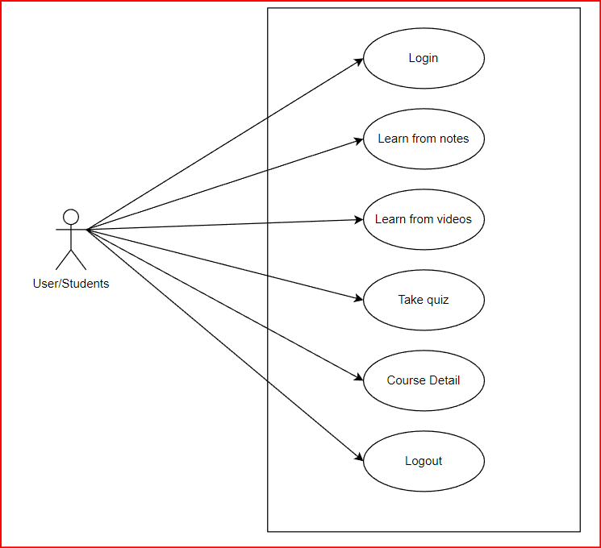

*Fig 2: Use case diagram of User/Student*

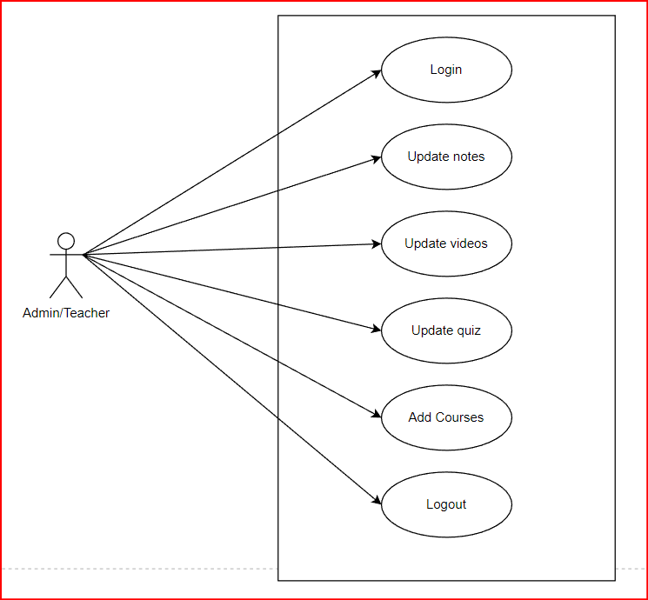

*Fig 3: Use case diagram of Admin/Teacher*

**2.2.1.2 Non-Functional Requirements**

1. **Usability**:

The system must be easy to operate and understand. It should have intuitive and responsive design.

1. **Reliability and Compatibility**:

The system must operate reliable while performing CRUD and other functions. The system should be compatible on all web browsers.

1. **Performance**

The system must maintain security of user credentials and data. There should not be any time lag while performing different operations

1. **Quality**

The quality of the system shall be moderate. The quality of the system shall be enough to attract the user.

1. **Performance or speed of the system**

The system’s performance on average will be good. The system shall provide 99% reliability. Similarly, the speed of the system will be fast. The system’s response time will be at least 0.5 seconds

* + 1. **System Requirements**

**2.2.2.1 Hardware Requirements**

Table 8: Hardware Requirements

|  |  |
| --- | --- |
| **Hardware** | **Purpose** |
| Processor (Minimum 2.5 Ghz core 2 Duo Processor | To process the data at a high speed |
| RAM (minimum 1 gb) | To process data such that there is no lag |
| Device (PC, Laptop) | To use application |

* + - 1. **Software Requirements**

Table 9: Software Requirements

|  |  |
| --- | --- |
| **Software** | **Purpose** |
| VS-code | In order to design layouts and to write code. |
| MYSQL: | In order to establish communication between data and database. |
| Microsoft-word : | To write documentation of project. |
| draw.io | In order to draw the diagram of ER-diagram, Use-case, Sequence  diagram, Activity diagram and so on. |

* + 1. **Solution Design** 
       1. **System Flow Diagram**

System flowcharts are a way of displaying how data flows in a system and how decisions are made to control events. To illustrate this, symbols are used. They are connected together to show what happens to data and where it goes.( *System Flowcharts - GCSE ICT Revision - BBC Bitesize*, n.d.)

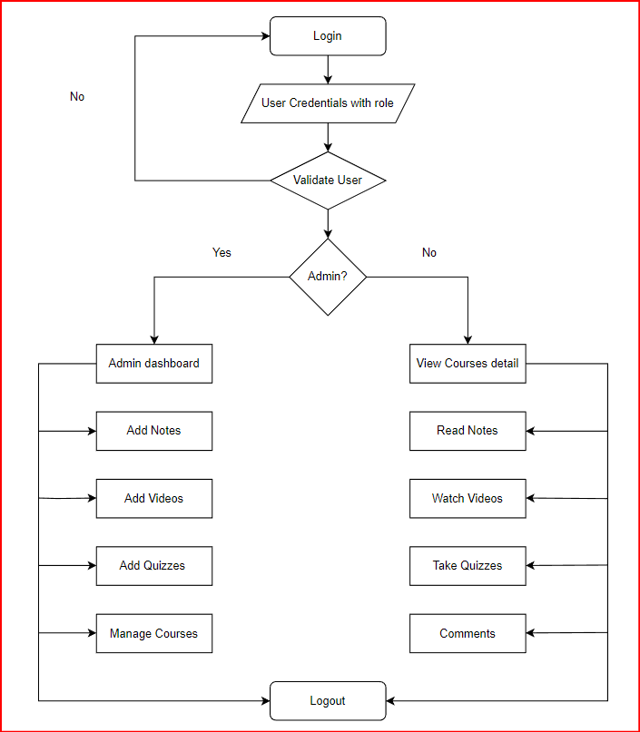

Figure 4: System Flow Diagram

* + - 1. **Context Diagram**

Context Diagram provides a basic overview of the whole system. It is the highest level in a data flow diagram and contains only one process, representing the entire system, which establishes the context and boundaries of the system to be modeled. It identifies the flows of information between the system and external entities.

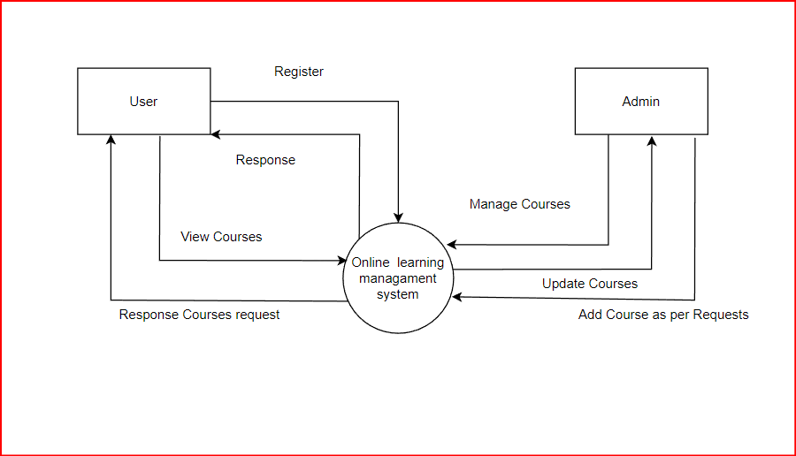

Figure 5: Context Diagram

The diagram is the Zero Level Data Flow Diagram (0 level DFD). It explains what can be done in the web application. Two entities: Admin and Users uses the website. The activities that can be done by the two parties are registration, login, view course, managing course.

### DFD Level 1

In DFD Level 1 the context diagram is decomposed into multiple /processes. In this level, the main functions of the system are highlighted and breakdown the high-level process of 0-level DFD into sub processes.

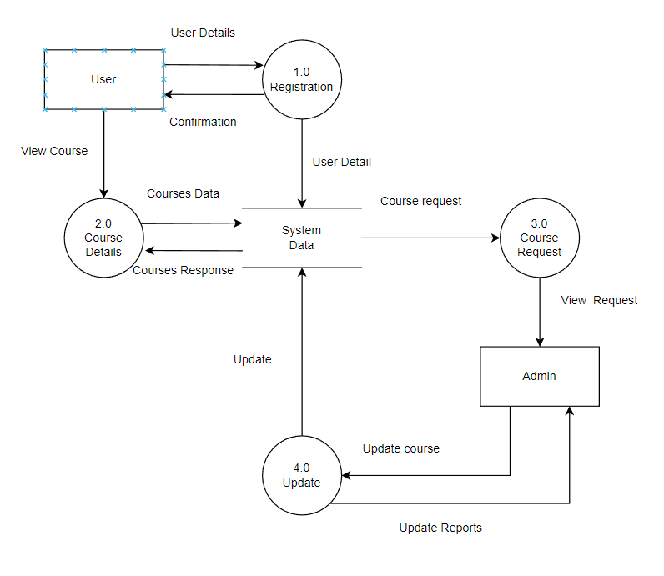

Figure 6: DFD Level 1

The above level 1 DFD provides the surface look of the system. The main function of the system are registration, courses details, updates, responding to requests.

### DFD Level 2

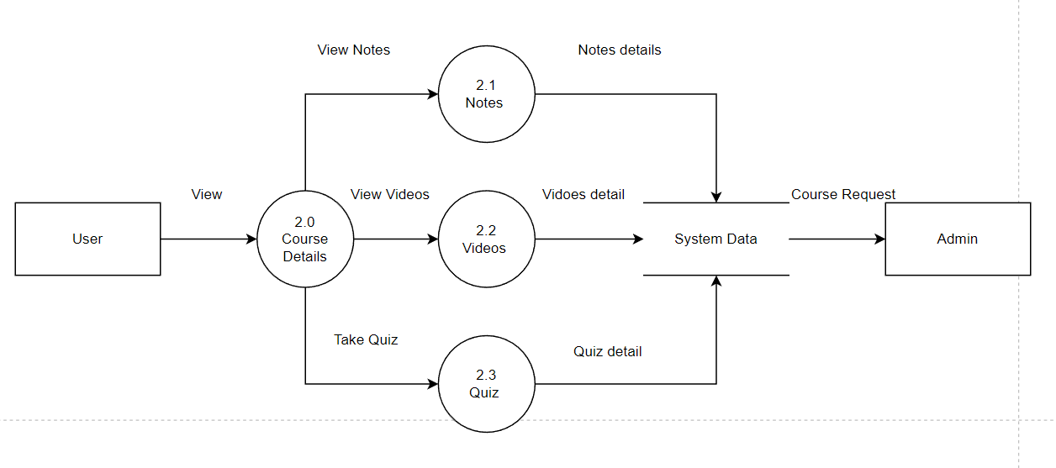A level 2 DFD offers a more detailed look at the processes that make up an information system than a level 1 DFD does. It can be used to project or record the specific/necessary detail about the system's functioning.

Figure 7: DFD Level 2 (Expanding 2.0)

The above figure shows the expansion of 2.0. Here, we emphasize the system’s major functions and break down the Course Details of DFD Level 1 into its sub-processes.

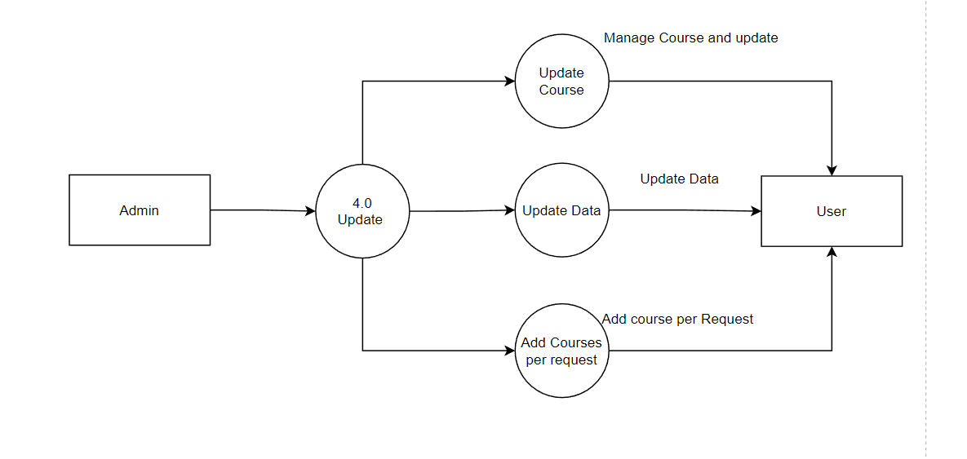

Figure 8: DFD Level 2 (Expanding 4.0)

The above figure shows the expansion of 2.0. Here, we emphasize the system’s major functions and break down the Update of DFD Level 1 into its sub-processes.

## Class Diagram

A class diagram is a type of UML (Unified Modeling Language) diagram that illustrates the structure and relationships of classes in a system or software application. It provides a visual representation of the classes, their attributes, methods, and the associations between them.

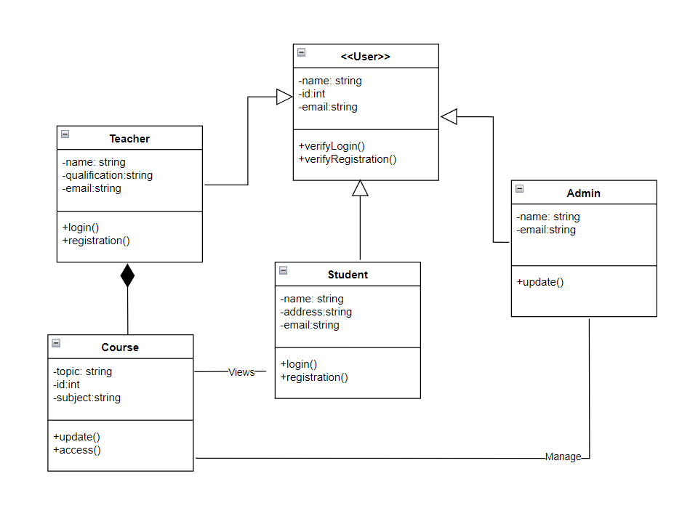

Figure 9: Class Diagram

The above figure show a class diagram with Teacher, Admin, Course, Student, User and their attributes, methods and associations between them. There is generalization between teacher, user, admin, student. Composition between teacher and course.

## System Design

Sequence diagram of Admin:

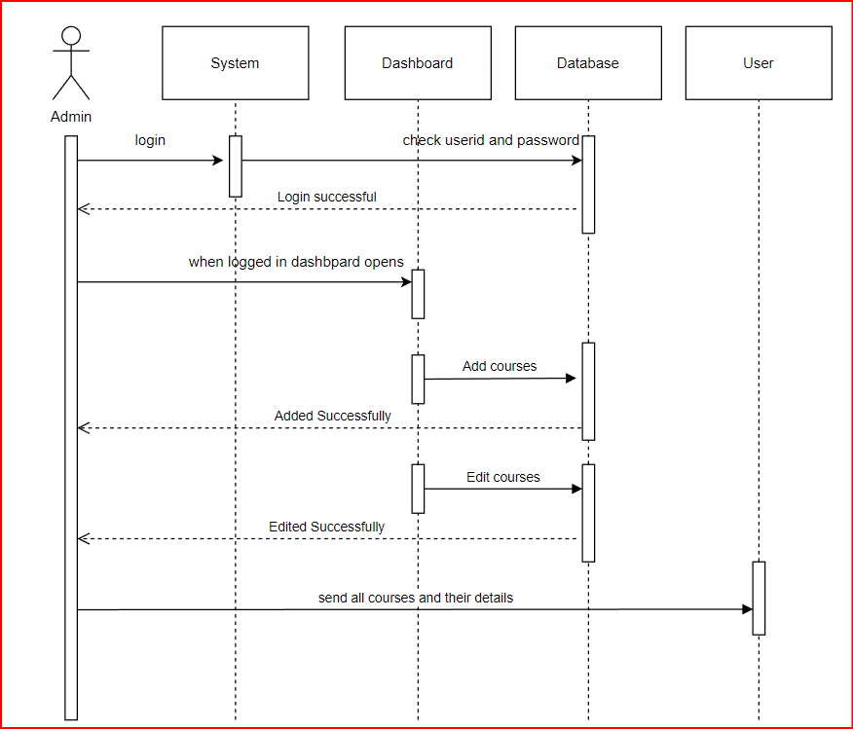

Figure 10: Sequence Diagram of Admin

This is the sequence diagram for an admin user. The admin user first has to login into the system. Then, the user can navigate to various pages from the navigation bar. Once logged in, the admin can access the dashboard and view, update and create courses.

Sequence diagram of User

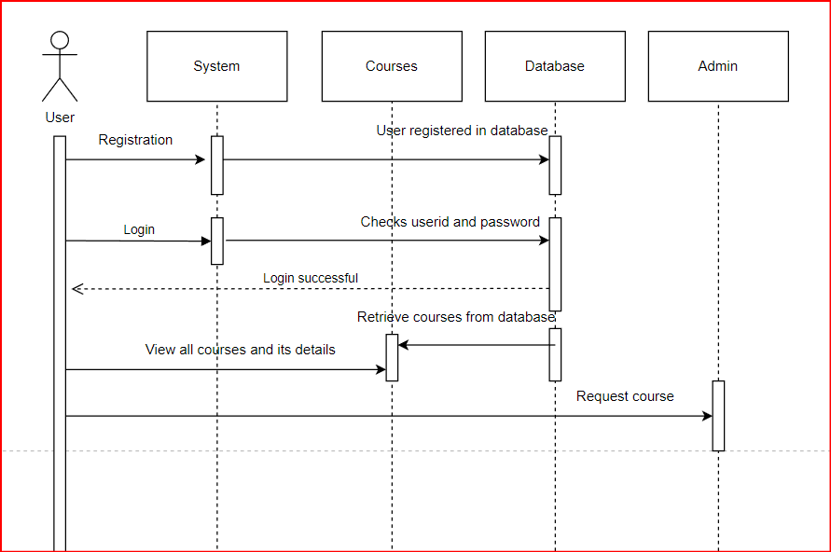

Figure 11: Sequence Diagram of User

This is the sequence diagram for a student user. The student user first has to login into the system. Then, the user can navigate to various pages from the navigation bar. Once logged in, the student can view courses. Similarly, they can view notes, videos and take quiz.

* + - 1. **Activity Diagram**

Activity diagram is basically a flowchart to represent the flow from one activity to another activity. The activity can be described as an operation of the system. The control flow is drawn from one operation to another. The basic purpose of activity diagrams is to capture the dynamic behaviour of the system**.** It models the concurrent and sequential activities (Activity Diagram, n.d).

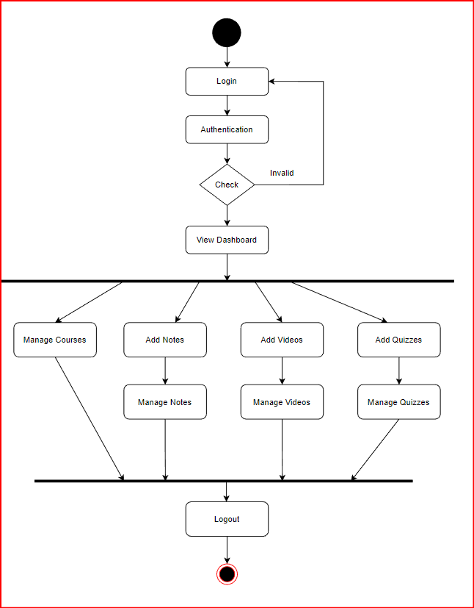

Figure 12: Activity Diagram of Admin

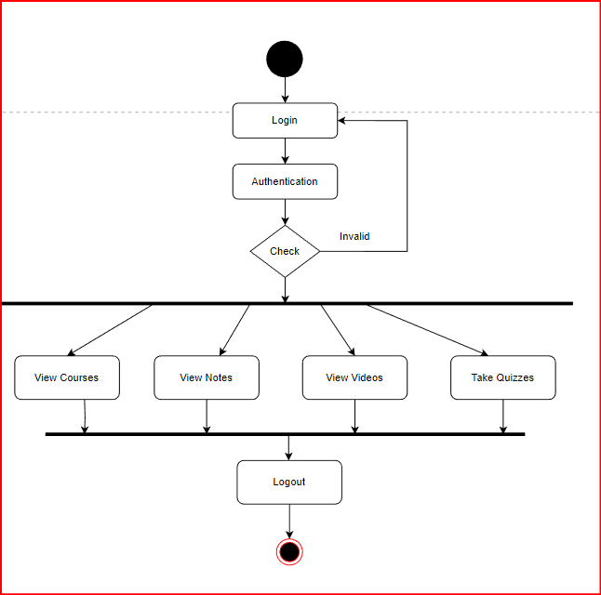

Figure 13: Activity Diagram of User

#### ER Diagram

#### 

Figure 14: ER-Diagram

An entity relationship diagram (ERD) is a diagram that illustrates the logical structure of databases. In a nutshell, it shows the relationships of entity sets stored in a db. An entity in this context is a component of data. (*Entity Relationship Diagram (ERD)* , n.d.)

In this project, we can observe there are six major entities. They are Student, Course, Admin, Notes, Videos and Quiz. We can observe relations among them course has notes, videos, quiz and students views these courses and admin manages them.

## Analysis of possible solutions

### Testing

Testing is considered to be one of the most important parts of system design, but it is often neglected and done half hearty. Tutorials point explains testing as: evaluation of the software against requirements gathered from users and system specifications. Testing identifies important defects, flaws, or errors in the application code that must be fixed. The author didn’t use traditional method of performing testing after the system was done built rather testing was conducted iteratively as system was being built which helped a lot in saving time.

### Purpose of Testing

System testing is a stage of implementation, which is aimed at ensuring that the system works accurately and efficiently as per the user need, before the live operation commences. As started before, testing is vital to the success of a system. The main goal of testing is to ensure that the system fulfills the requirements and system specifications. No system is perfect. So, testing is necessary to identify all the defects and possible errors. We then fix those issues. Testing is basically composed of validation and verification. It makes a logical assumption that if all parts of them as system are correct, the goal will be successfully achieved. A series of tests are performed before the system is ready for the user acceptance test.

### Verification and Validation

Software testing is used in association with verification and validation. Verification was done for checking of or testing of items, including software, for consistency with an associated specification. Validation was done for checking what has been specified is what the user wanted.

## Level of Testing

### Unit Testing

Unit testing means testing components of system in isolation. The module is taken and tested in isolation from rest of the software product by using prepared test cases and comparing actual results with the result predicted by the specifications and design of the module. Each time some code was written, it was run and monitored for the bug. As bugs were discovered, they were corrected by adding additional code or modifying the existing code. Several bugs were corrected by analyzing the error messages and correcting them by chaining in code. After the development of the system has been completed, testing was also performed. Functionality testing and interface testing were combined to ensure the system was functioning as required.

Some of the general test cases that have been conducted in the system are:

* + - * + Ensuring that the admin and guest can login into the system.
        + Ensuring that the admin can add/delete courses.
        + Ensuring that the user can view the courses and details.

### Integration Testing

Integration testing is defined as the testing of combined parts of an application to determine if they function correctly. Integration testing was applied to this project by testing the integration between the database and the main application. Integration testing between the movie upload and database was also performed. Integration needs to be read from the database and also inserted into the database by the main application for the system to work successfully as intended.

### System Testing

System testing is conducted on a complete, integrated system. This was done to test a completely integrated system to verify that it meets its requirements. It involves end-to-end testing of a system to find the behavior of a system with respect to expectations. It needs to be done by developers as if they are the users of the system. The testing process involves defining test scenarios, test cases and test data for testing. System testing is actually a set of processes which may include functionality, user interface, performance and security testing. Test cases are defined by referring to requirements and designs. Following test cases are tested:

Table 10: Test Case

|  |  |  |  |  |  |  |
| --- | --- | --- | --- | --- | --- | --- |
| S.N | Case id | Test Description | Steps  Executed | Expected Result | Actual Result | Pass  /Fail |
| 1 | TC-01 | Entering incorrect password | Incorrect email and/or passwords should be entered | A bar saying incorrect email or password should be displayed. | A bar saying incorrect email or password was displayed. | Pass |
| 2 | TC-02 | Clicking the courses icon in the courses section . | Click the course icon. | Course page should be navigated to. | Course page was navigated to. | Pass |
| 3 | TC-03 | Clicking the notes in the notes page. | Click the notes to read. | Notes page should be navigated to. | Notes page was navigated to. | Pass |
| 4 | TC-04 | Clicking the video in the video page. | Click the video . | Video should be played. | Video was played. | Pass |
| 5 | TC-05 | Clicking the quiz icon in the course section. | Click the quiz icon. | Quiz should be navigated to. | Quiz page was navigated to. | Pass |

###### Test case 1: Admin log in page

To access admin panel, one has to login using admin’s login details

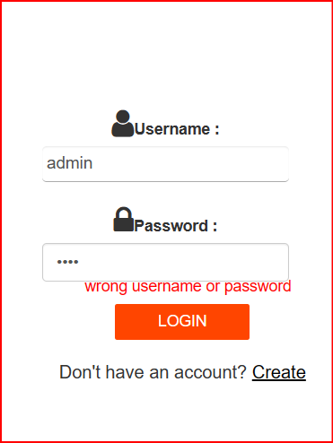Username-admin

Password – admin

Figure 15: Admin Login

**Conclusion:** Figure 15 contains a admin login page where admin needs to fill up the user name and password to login. When the username and password doesn’t match, it show the error.

###### Test case 2: Add Course

Figure 16:Add Course

###### Test case 3: Add Course Validation

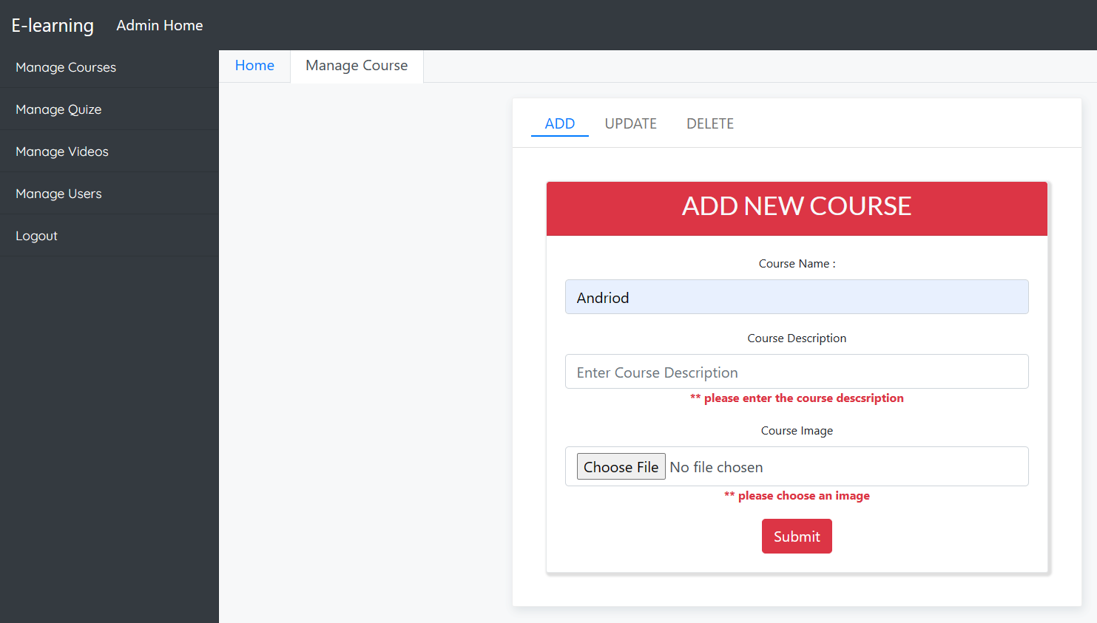

Figure 17: Add Course Validation

**Conclusion:** Figure 17 consist of page where admin can add course without filling in the fields so it shows error.

###### Test case 4: User registration page

To access user panel, a user has to registered, if he/she is registered if may login to the system and access the user panel or user dashboard.

Username-ram

Password –ram

###### Registration page:

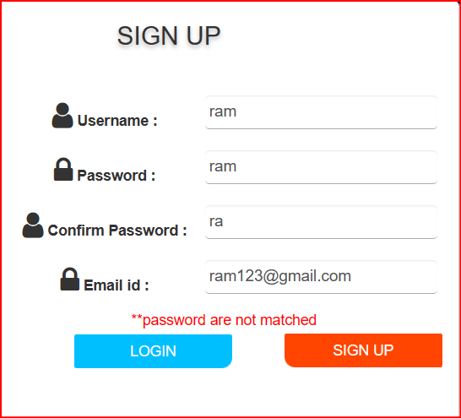

Figure 18: User registration

**Conclusion:** Figure 18 contains a registration page where user needs to fill up the user name and password, email to register. When the passwords and other fields doesn’t match, it show the validation error.

**Test case 5: Login page of User**

After the user is registered the he/she can log into his/her account and access the website using the registered username and password.

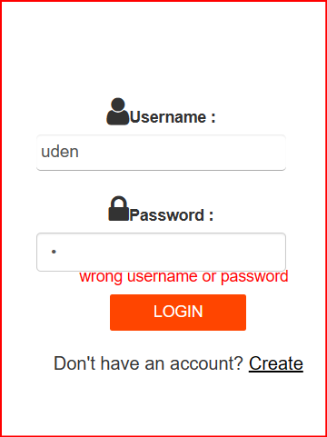

Figure 19:User Login

**Conclusion:** Figure 19 contains a user login page where user needs to fill up the user name and password to login. When the passwords and other fields doesn’t match, it show the validation error.

## Findings/Result

### Output

The following are the outputs that we received from the part of the application:

###### Test case 1: Homepage

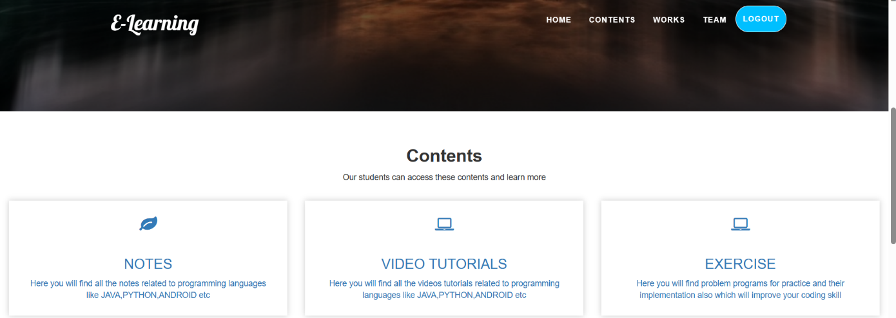

Figure 20: Home Page

**Courses**

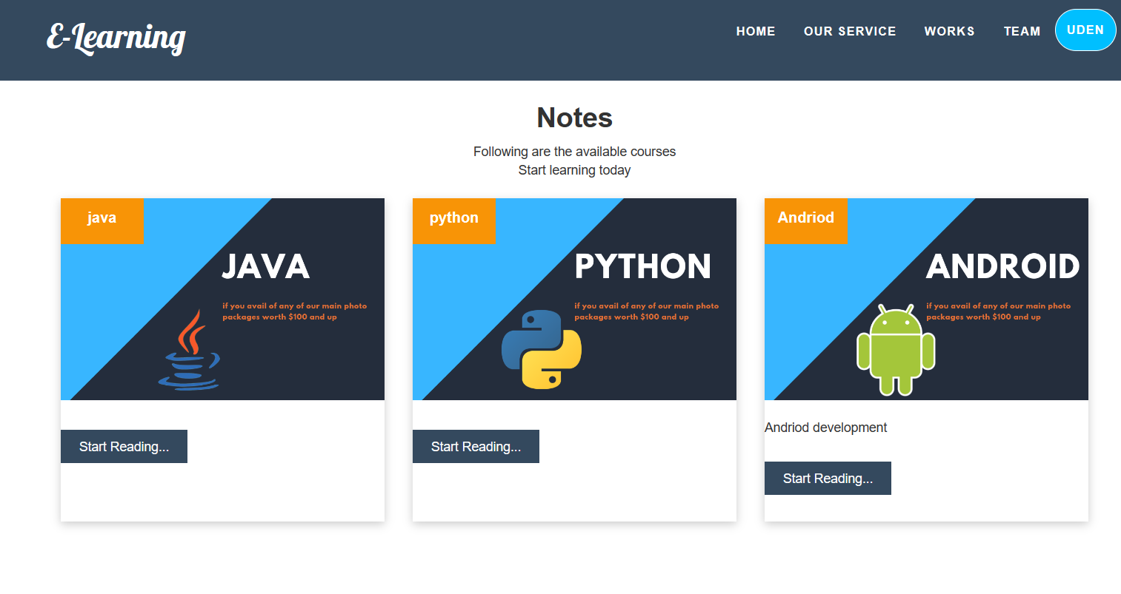

Figure 21:Course Page

###### Admin’s dashboard

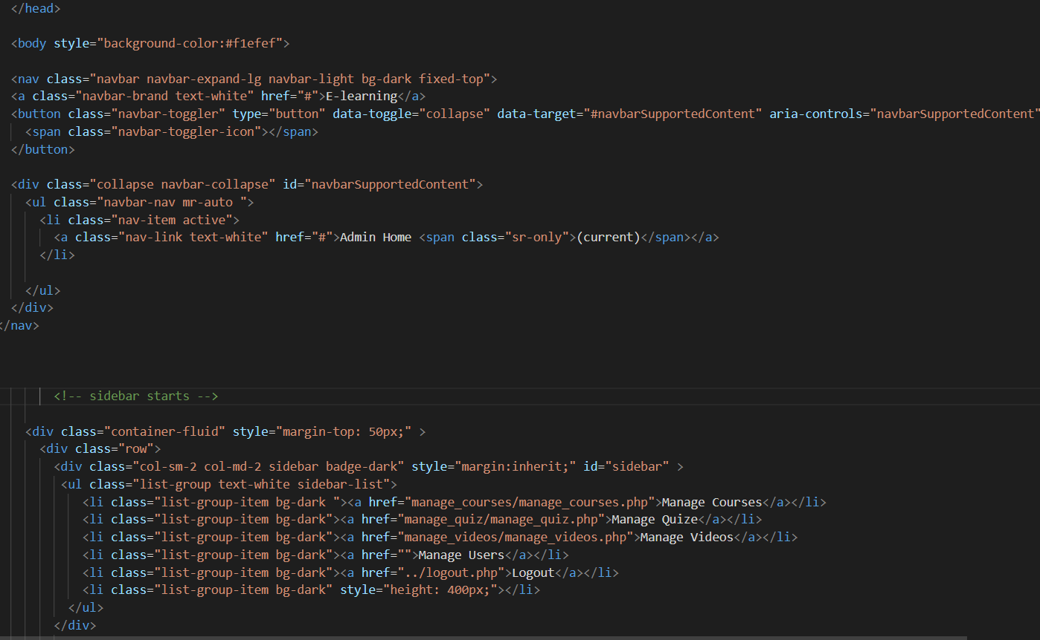

**Expected outcome**

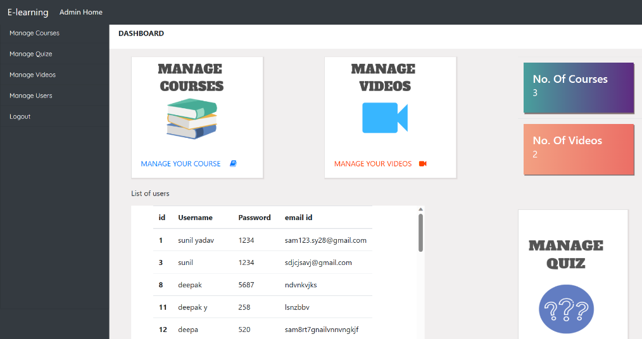

Figure 22: Admin dashboard

**Conclusion:** Figure 22, after admin login into the page he/she can see the admin dashboard and manage various contents of page

**Notes Page**

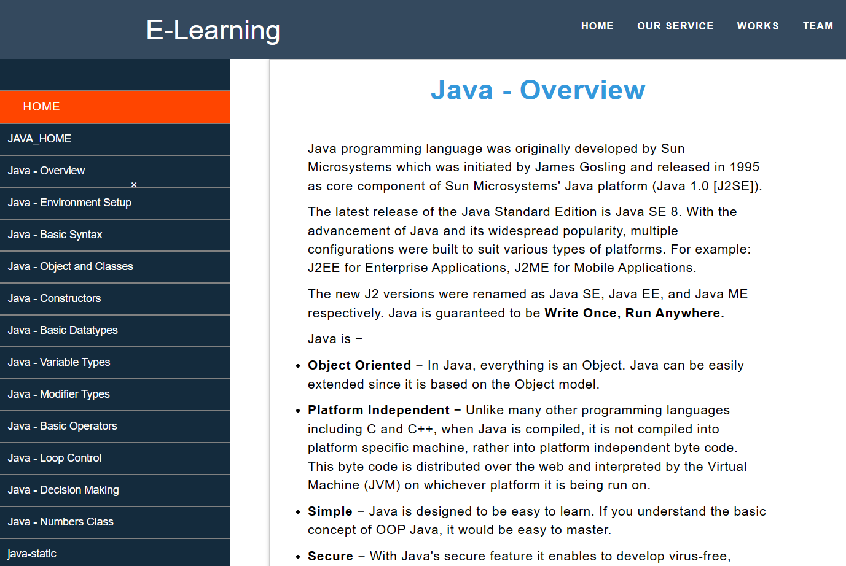

Figure 23:Notes Page

**Conclusion**: Figure 23 contains notes page where the students can obtain and read notes for various subjects that are updated by the teachers

**Videos Page**

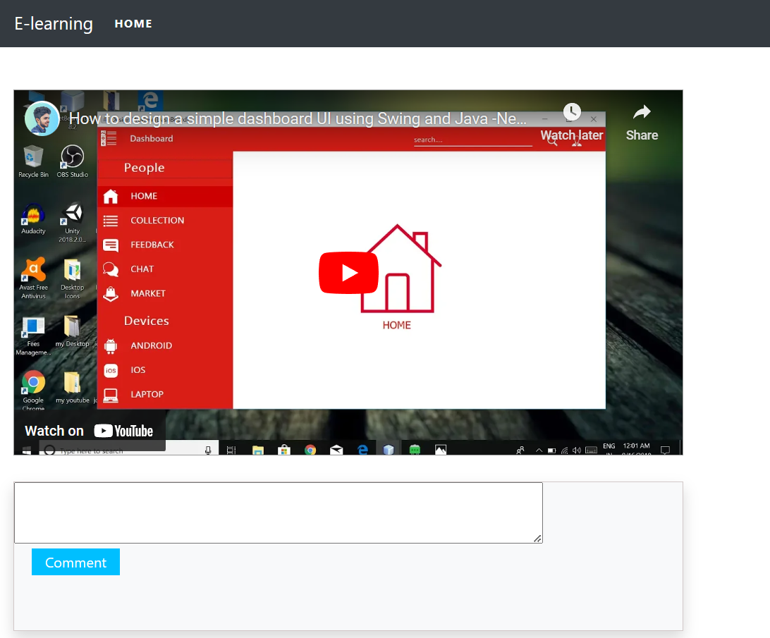

Figure 24:Video Page

**Conclusion**: Figure 24 contains videos page where the students can obtain and view videos for various subjects that are updated by the teachers

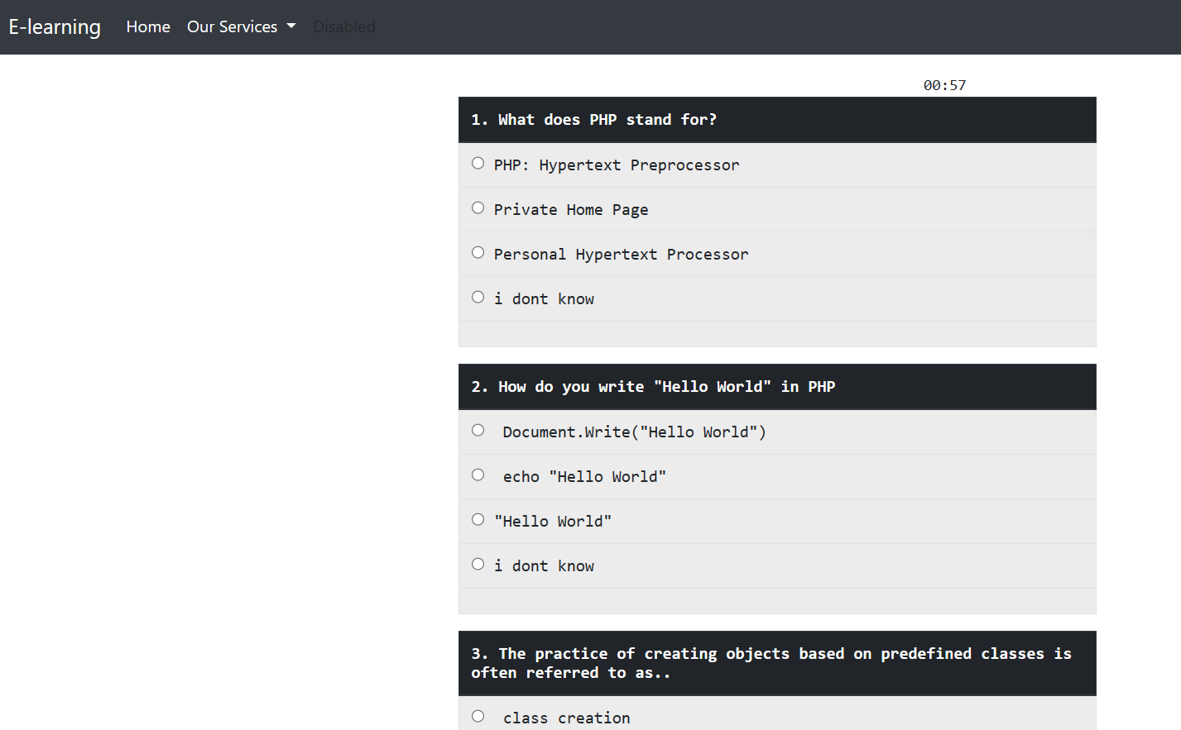**Quiz page**

Figure 25:Quiz Page

**Conclusion**: Figure 25 contains quiz page where the students can take quiz to take tests if they fully understood the subject matter.

* 1. **Discussions**

# Chapter 3 – Discussion and Conclusion

### Critical Analysis

The main aim of this project is to enable learners to access educational resources anytime, anywhere, and offer educators tools to create engaging and interactive learning experiences. Online learning have gained significant popularity in recent years due to the growth of e-learning and distance education. These systems provide a platform for educational institutions, trainers, and organizations to deliver courses and educational content to learners in a virtual environment. Online learning management systems have revolutionized education by providing accessible and scalable platforms for delivering quality education globally.

The Online Learning Management System offers a comprehensive and scalable solution for delivering, managing, and tracking online courses and training programs. Its user-friendly interface, extensive features, and mobile compatibility make it an ideal choice for educational institutions and organizations seeking to enhance their training capabilities. With the potential to reduce costs, improve learner engagement, and streamline administrative tasks, the project is poised to contribute to the success of online learning initiatives.

### Assumptions

The end product of my project is a web-based application using PHP and MySQL which is a platform to learn new things online thorough internet. It assumes following features:

* + - 1. User has a internet connection
      2. Only valid information will be filled in while entering data.

### Limitations

Some of the limitation of this project are:

* + - 1. This application needs an internet connection to function.
      2. No option to choose language.

### Future enhancements

1. Adding featured functionality in the homepage
2. Virtual classes
3. Rating system
   1. **Conclusion**

Online Learning Management System is a website which enables users to view and learn from different courses and their contents. The users will be able to browse through the website using any web browser. The users must need to register in order to learn. Then the users can browse through the website and choose which course they want to study. All the tasks happening in the website are recorded in the database. The system provides a user friendly interface to both the admin and customers.

This project has been a great opportunity to enhance skill towards real life situation. This not only has helped in completion of project for academic purpose but also has helped to develop software managerial skills necessary to succeed in the challenging and competitive job environment. This project gave me an opportunity to get more familiar with how IT is actually adopted in real world. Also, this project can be enhanced in the future for the upcoming changes in the business environment.

This project was a great learning experience as I got to learn about the know-how of IT in the business world as well as enhance my knowledge.

## REFERENCES

Craig, E. M. (2007). Changing paradigms: Managed learning environments and web 2.0. Campus-Wide Information Systems, 24(3), 152-161.

Falvo, D. A., & Johnson, B. F. (2007). The use of learning management systems in the United States. TechTrends, 51(2), 40-45.

Grob, H. L., Bensberg, F., & Dewanto, B. L. (2004). Developing, deploying, using and evaluating an open source learning management system. Journal of Computing and Information Technology, 12(2), 127-134.

Heirdsfield, A., Walker, S., Tambyah, M., & Beutel, D. (2011). Blackboard as an online learning environment: What do teacher education students and staff think? Australian Journal of Teacher Education, 36(7), 1.

Herrington, J. (2006). Authentic e-learning in higher education: Design principles for authentic learning environments and tasks.

*Entity Relationship Diagram (ERD) - What is an ER Diagram?* (n.d.). Retrieved June 3, 2022, from https://[www.smartdraw.com/entity-relationship-diagram/](http://www.smartdraw.com/entity-relationship-diagram/)

Lonn, S., Teasley, S. D., & Krumm, A. E.Who needs to do what where?: Using learning management systems on residential vs. commuter campuses. Computers & Education, 56, 642-649. doi: 10.1016/j.compedu.2010.10.006

Mafuna, M., & Wadesango, N. (2012). Students' acceptance and experiences of the new learning management system (LMS)-wiseup

Shahron Williams, v. R. Higher education sub-cultures and open source adoption. Computers & Education, 57, 1171-1183. doi: 10.1016/j.compedu.2011.01.006

Wagner, N., Hassanein, K., & Head, M. (2008). Who is responsible for e-learning success in higher education? A stakeholders' analysis. Educational Technology & Society, 11(3), 26-36.

*AVM School*. (n.d.). Retrieved March 22, 2023, from https://[www.avm.edu.np/](http://www.avm.edu.np/)

Systems Analysis: Definition & Example. (2017, April 24). Retrieved from [https://study.com/academy/lesson/systems-analysis-definition-example.html.](https://study.com/academy/lesson/systems-analysis-definition-example.html)

Odhiambo, D. (n.d.). System Design in Software Development. Retrieved from https://medium.com/:<https://medium.com/the-andela-way/system-design-in-software-> [development-f360ce6fcbb9](https://medium.com/the-andela-way/system-design-in-software-development-f360ce6fcbb9)

Software Testing Overview. (n.d.). Retrieved from https://[www.guru99.com:](http://www.guru99.com/) https://[www.guru99.com/software-testing-introduction-importance.html](http://www.guru99.com/software-testing-introduction-importance.html)

Usecase Diagram. (n.d.). Retrieved from https://[www.tutorialspoint.com:](http://www.tutorialspoint.com/) <https://www.tutorialspoint.com/uml/uml_use_case_diagram.html>

Sommerville, I. (2011). *Software Engineering (9th ed.; Boston, Ed.). Massachusetts: Pearson Education.*

**APPENDICES**

**Questionnaire**

Did the teaching methods used by instructors effectively facilitate your learning?

Did the instructors use various instructional techniques to cater to different learning styles?

Did you find the course materials (e.g., textbooks, handouts, supplementary readings) useful and informative?

Were the resources readily available and accessible to support your learning?

How are you learning new courses that are out of syllabus?

Did you receive timely and constructive feedback on your assignments and assessments?

Did the traditional learning system provide you with the necessary flexibility to manage your schedule?

Did you have access to additional resources or materials outside of the classroom?

On a scale of 1 to 10, how satisfied were you with your experience of the traditional learning system?

How would you rate your overall experience with the traditional classroom learning system?

Were the grading criteria and expectations clear and well-communicated?

Which learning environment (traditional or online) do you find more engaging and conducive to your learning style?

Which learning system provides you with greater flexibility in terms of schedule and location (traditional or online)?

What type of new things that the students want to learn more?

What features do you consider essential in an online learning platform?

What types of online courses have you taken in the past?

Would you prefer a more structured course with fixed deadlines or a self-paced course without strict deadlines?

What improvements or new features would you like to see in online learning platforms in the future?